**Cloud Project – Deploying and Exposing a NodeJS Application to the external world.**

Step 1: Firstly, we need to clone the project in our local host/machine. So, go to the GitHub repo and clone the project.

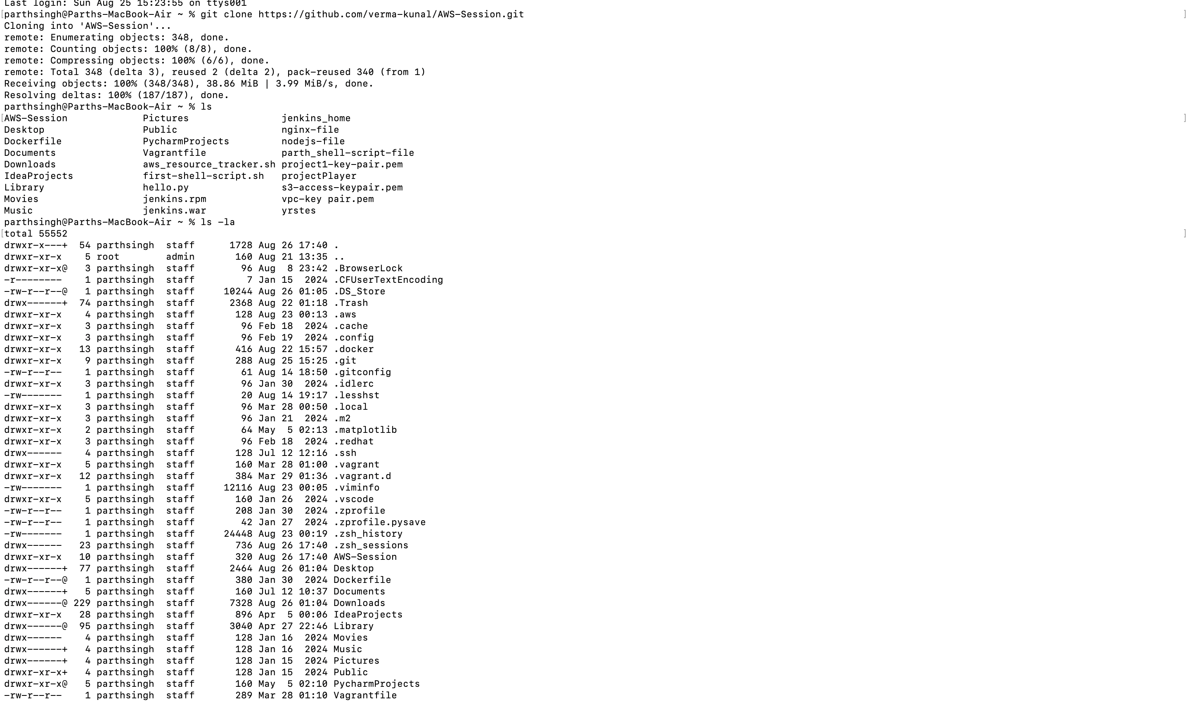

Step2: Now, we need to first deploy the project in our own local host. So, for that we need to open our project in Vs-Code.

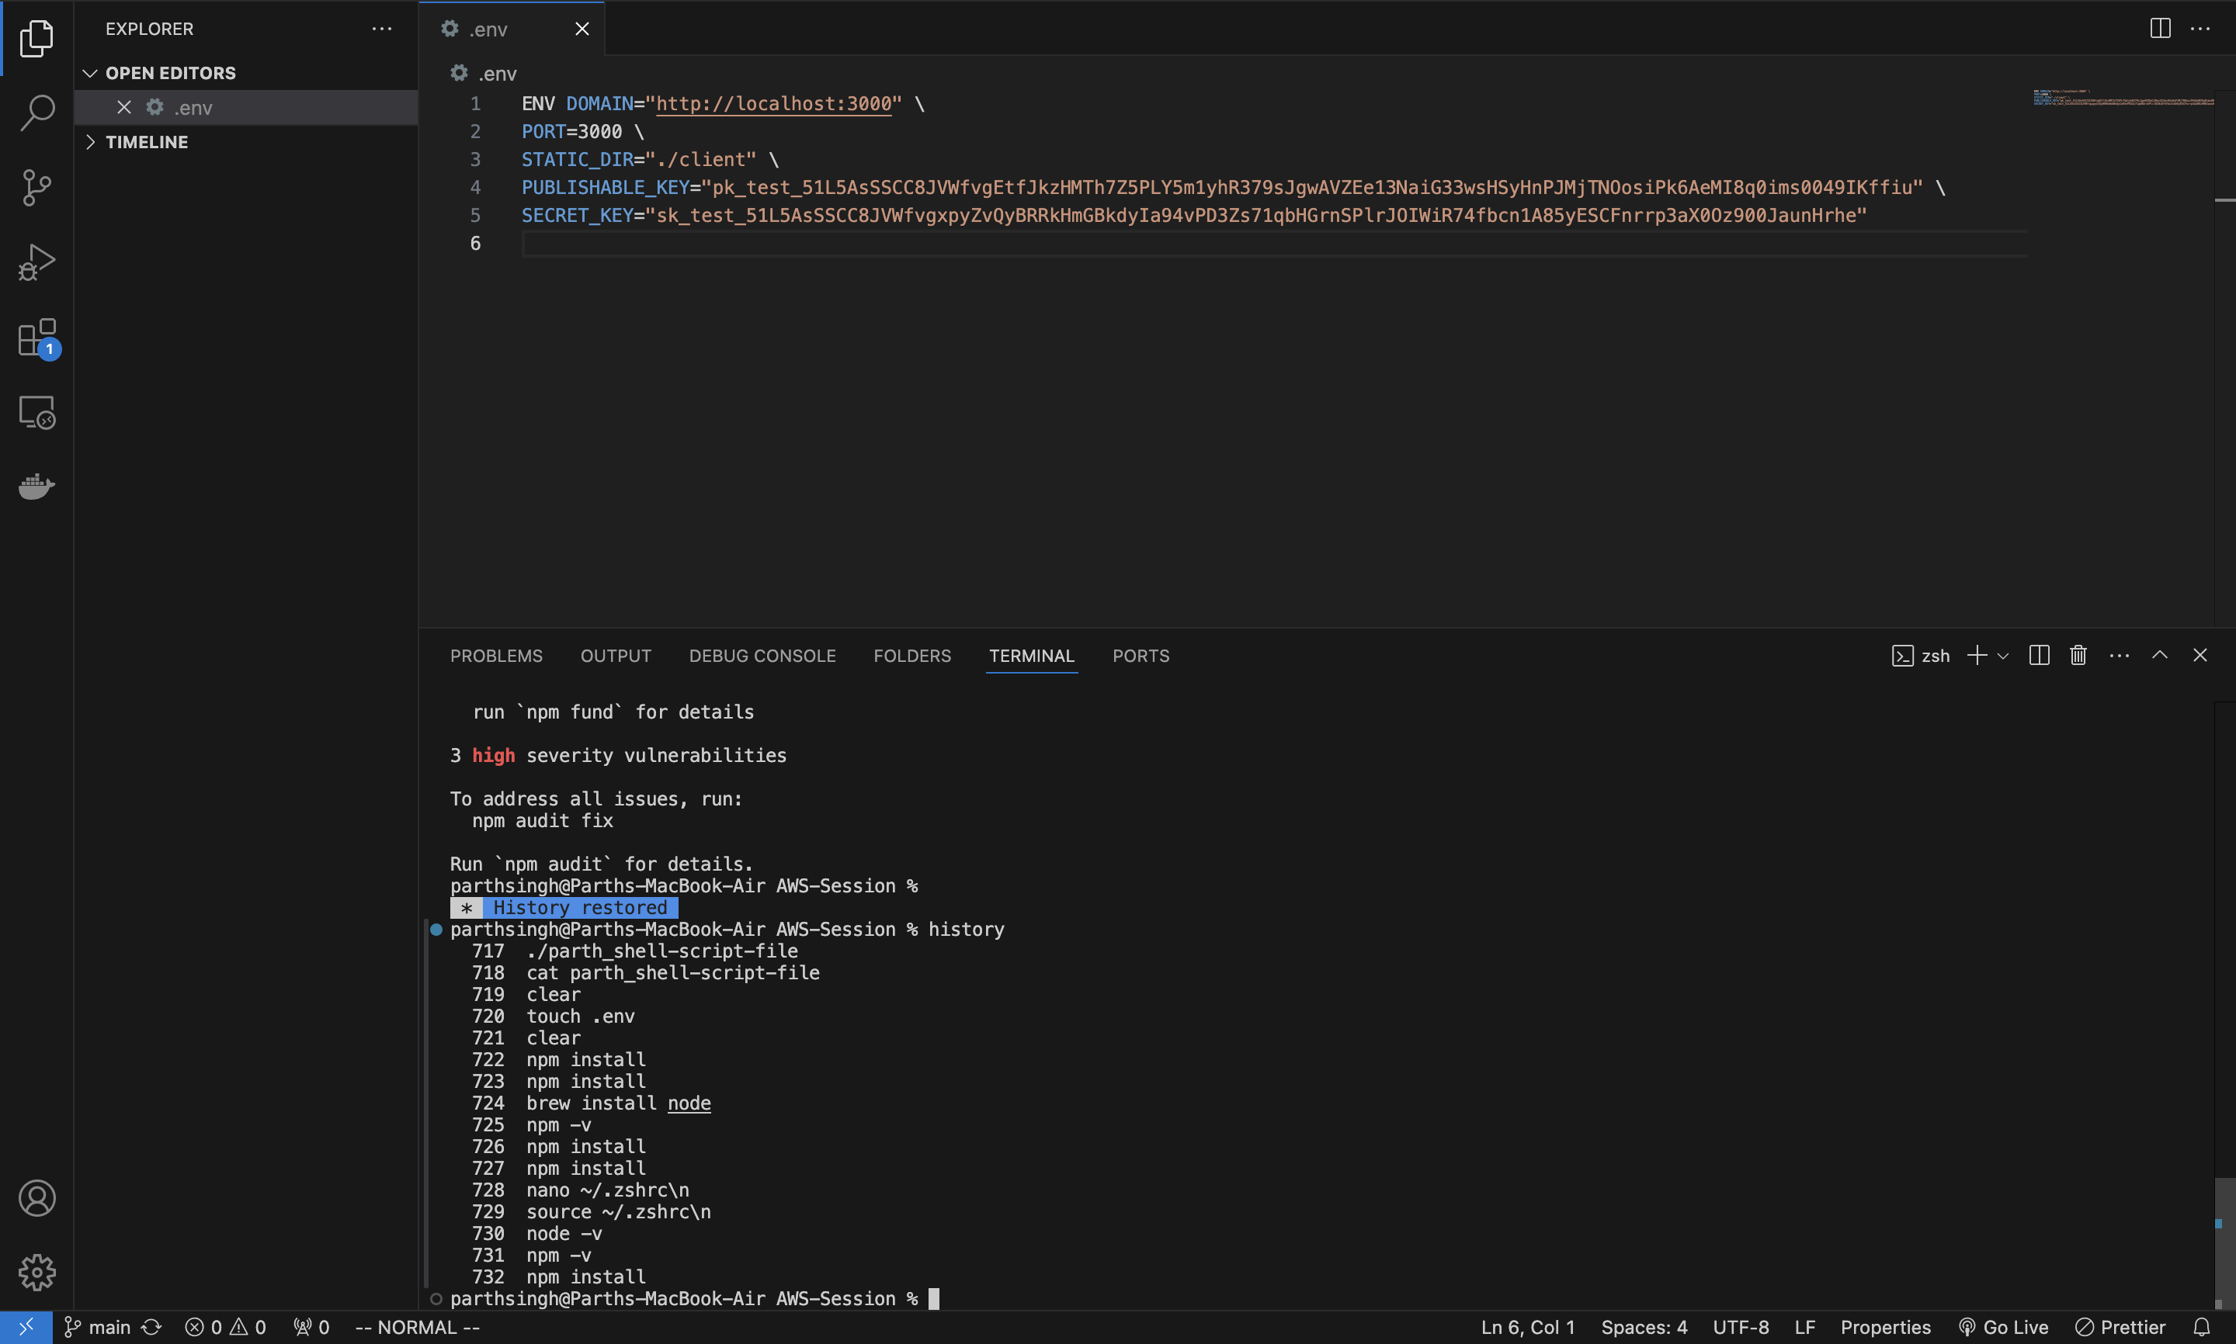

Step 3: Now, we need to create an environment file because this project contains security keys, and we can’t deploy this project without creating an environment file.

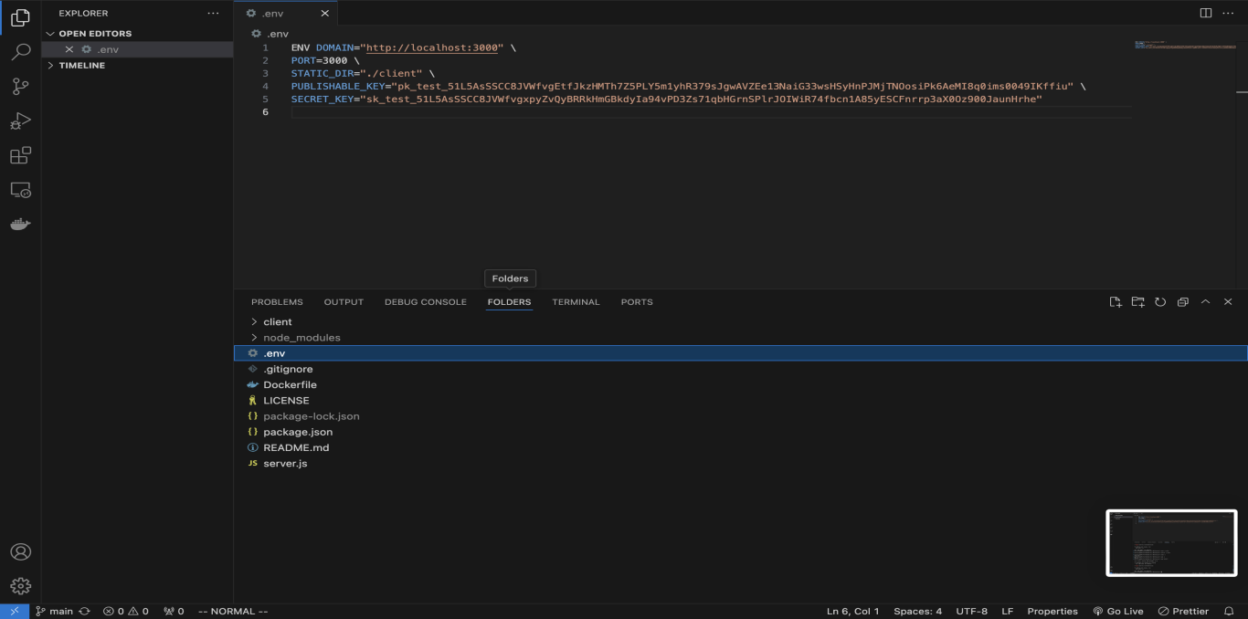

Step 4: Now, we need to install NodeJS and npm in our system then we would be able to execute commands to deploy the project in our local host.

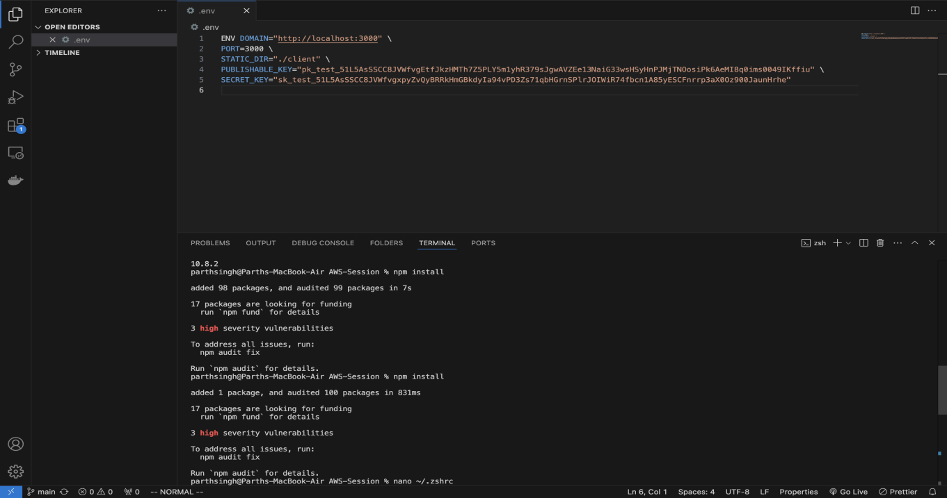

Step 5: Now, we are creating Iam user and allowing him the administrator permission. So, that he/she can login through those credentials and would be able to use only those services of aws which we have given access to them.

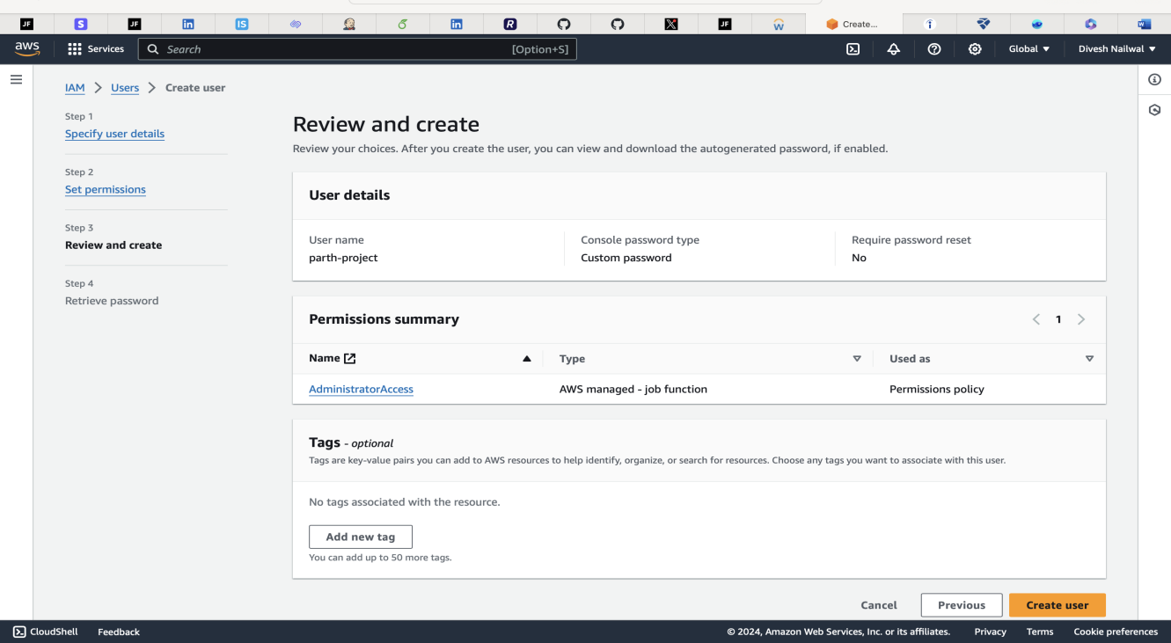

Step 5.1: Now, setting permission.

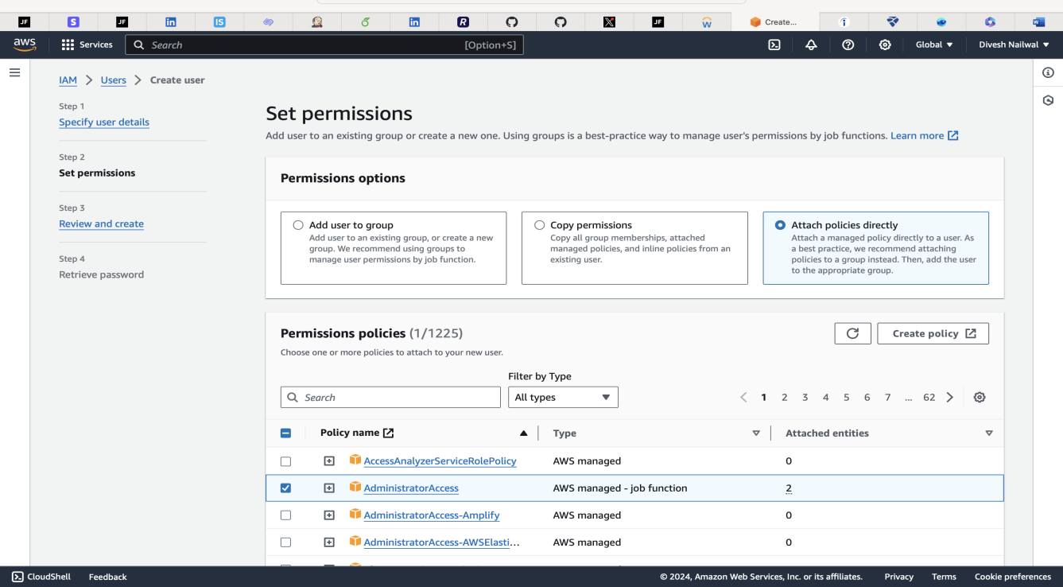

Step 5.2: Username and password generated.

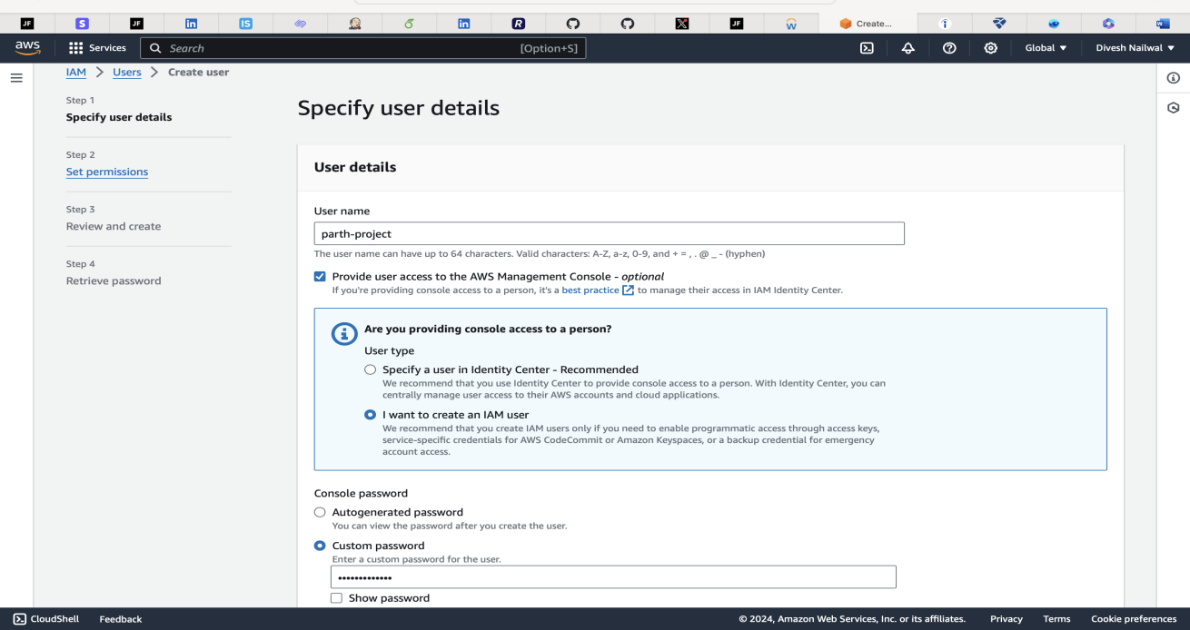

Step 5.3: Finally, logged-in to aws as an Iam user.

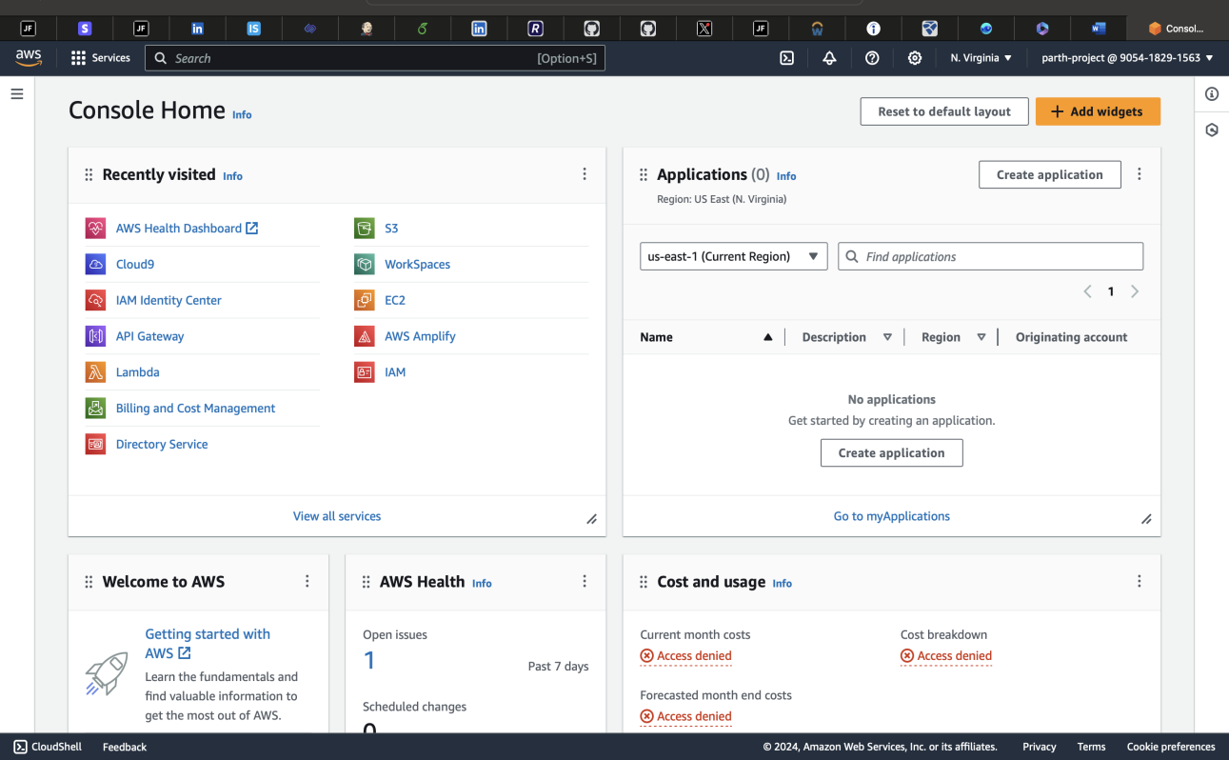

Step 6: Now, creating and launching an ec2-instance, choosing ubuntu as an operating system.

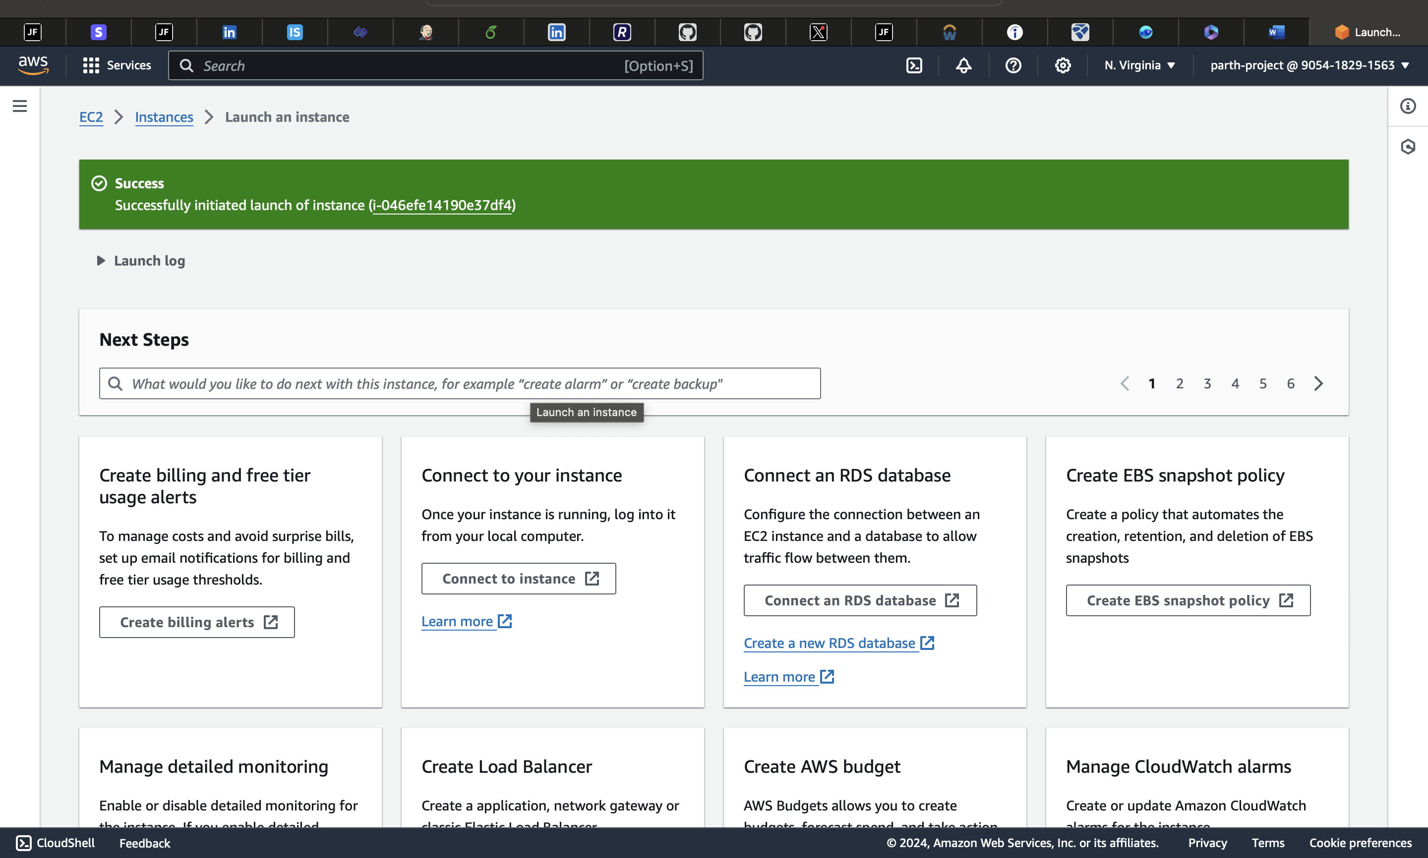

Step 7: Now, opening that ec2 instance in our cli(terminal). And, for the permission purpose chmod command is used.

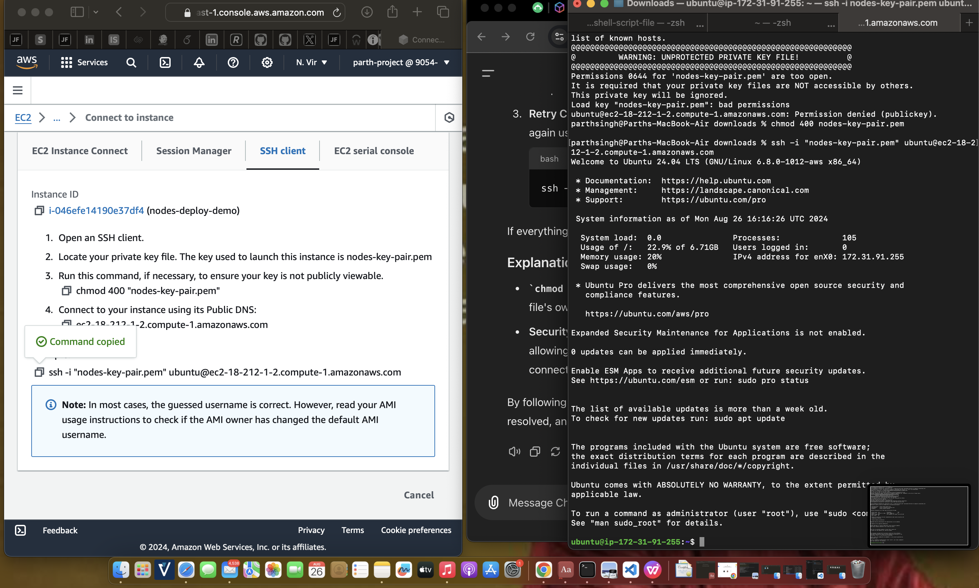

Step 8: After that, when we entered ec2 ubuntu server. Now, just starting with a generic command (Sudo-apt-update). So, that it can update all the necessary packages.

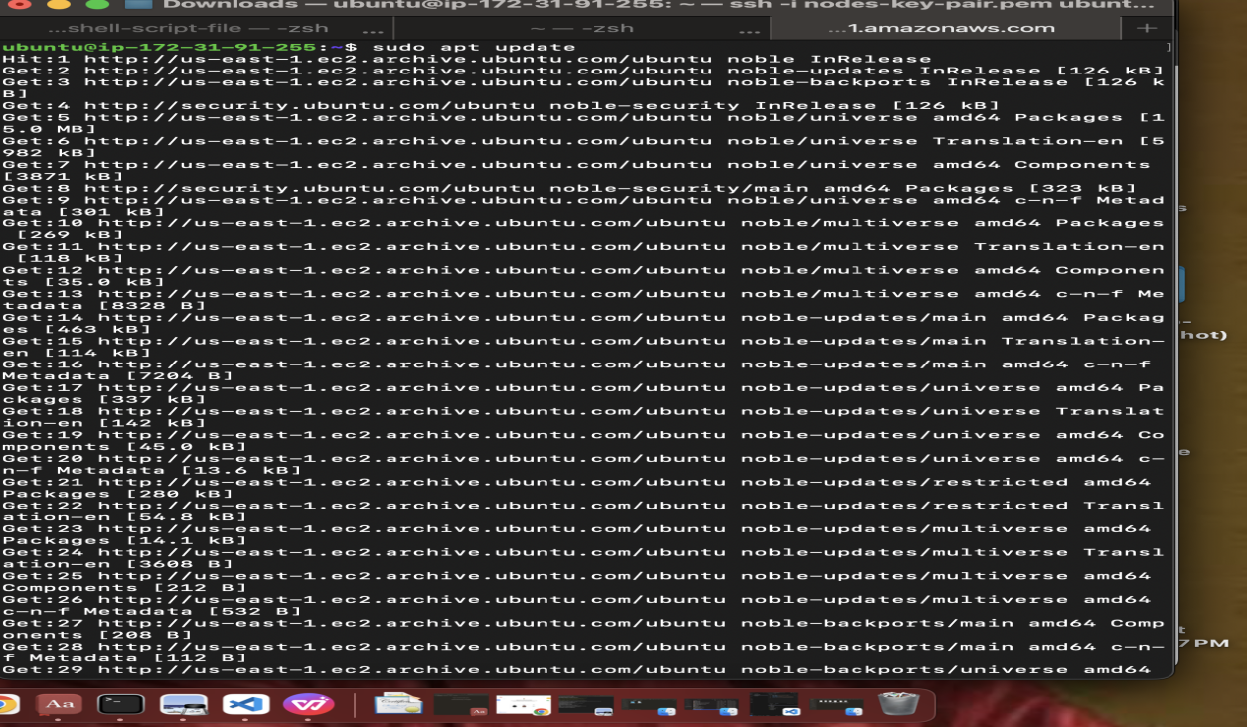

Step 9: Now, we must install NodeJS and npm inside our ubuntu server.

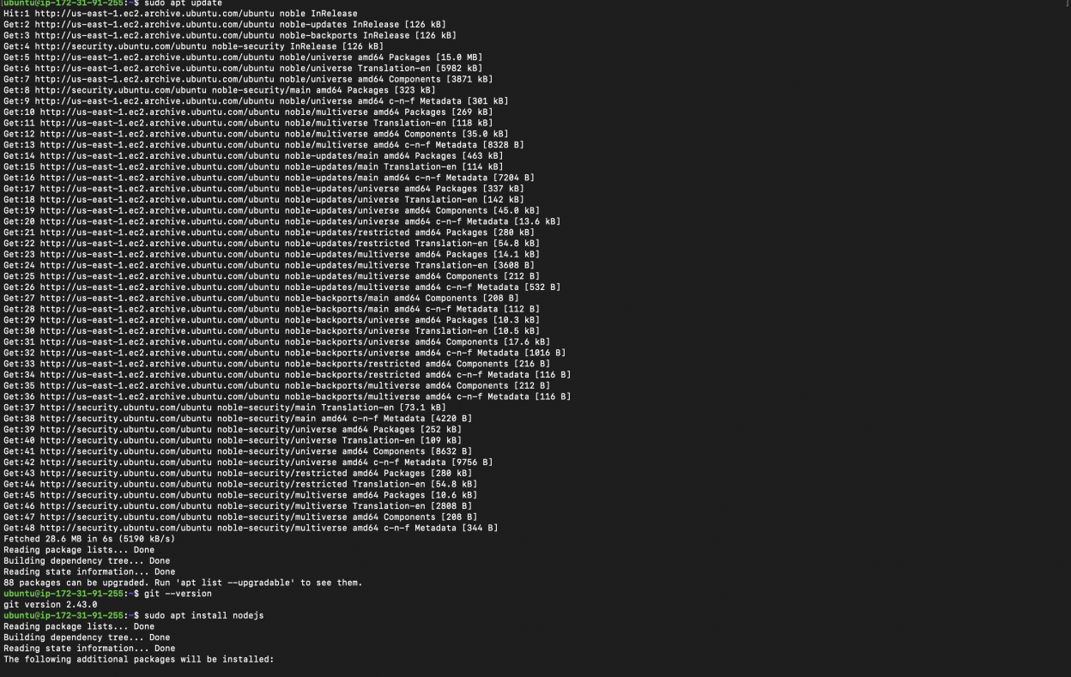

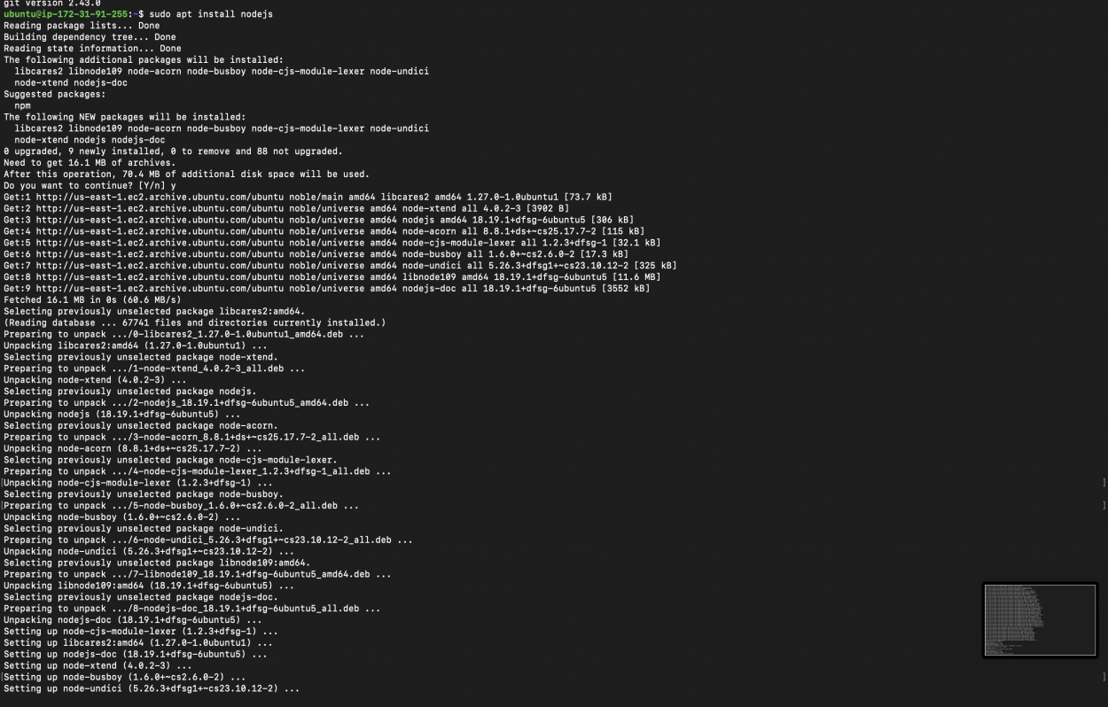

Step 9.1: Now, we will check the version of NodeJs and now we will install npm as well.

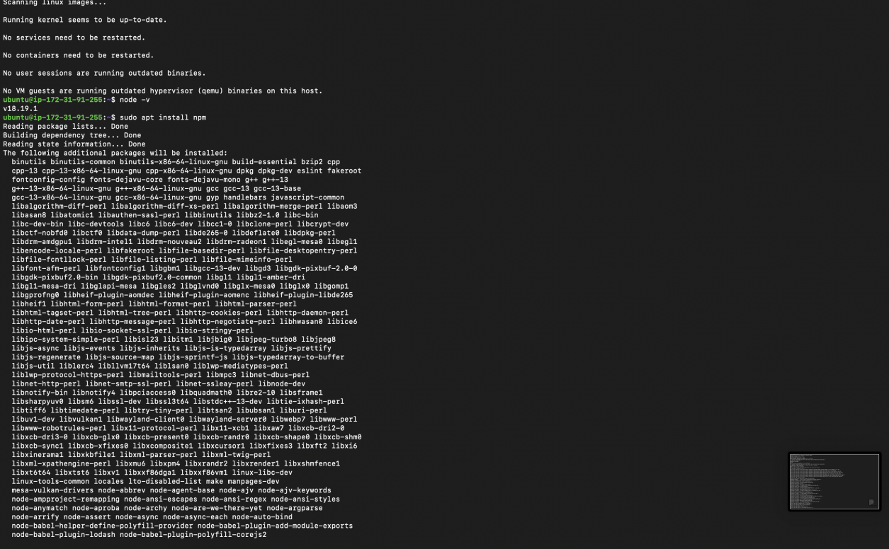

Step 9.2: Now, we will clone the project inside our ubuntu server.

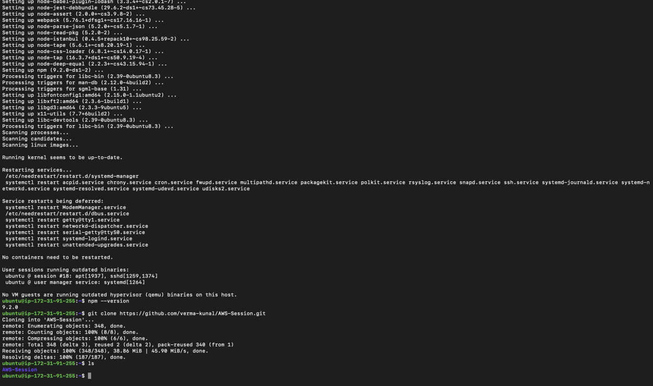

Step 10: Now, we will execute the command npm run start.

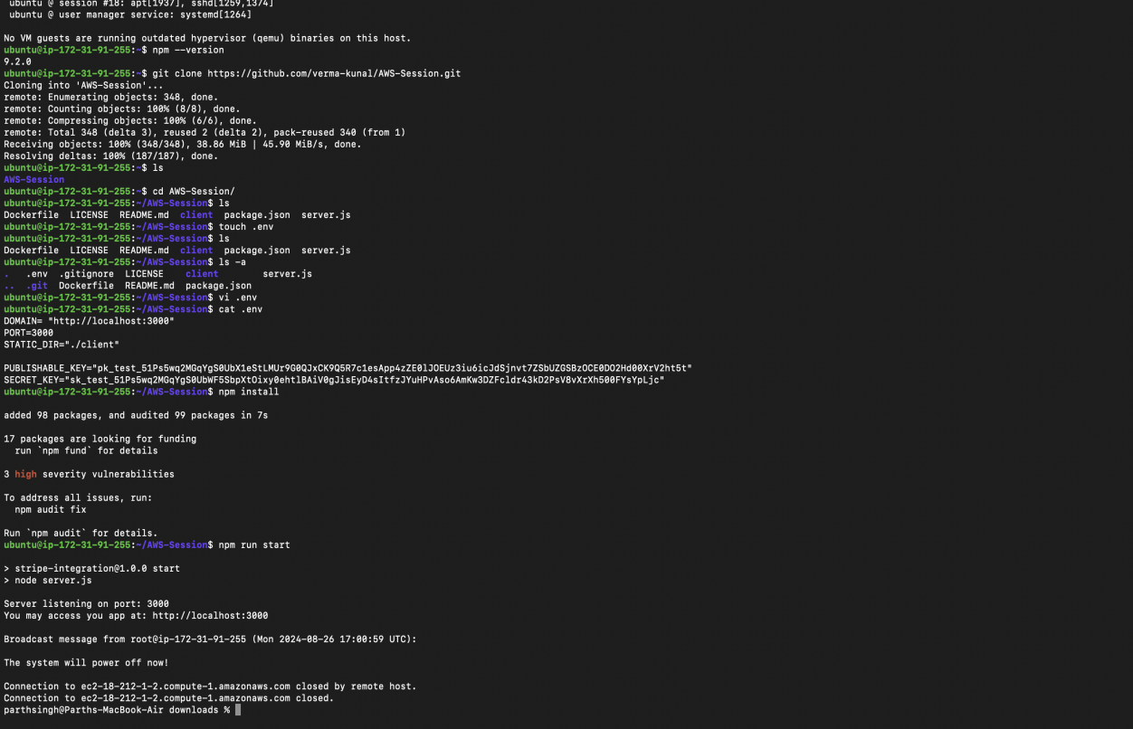

Step 11: Now, if we try to access our project on the internet with the help of URL, it wouldn’t open. Because, we have not given permission to expose ports publicly. So, we need to go to security groups of ec2 instance and add one inbound rule.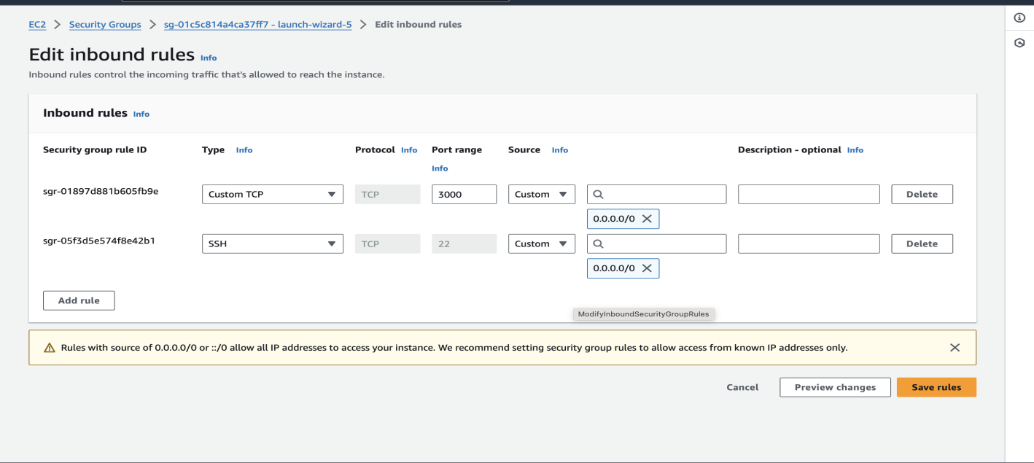

Step 12: And now if we copy the Private Ip of the ubuntu instance and paste it on our internet publicly. Our application will run successfully, and we are able to see the UI of the application in our laptop screen.

